VBA Challenge

Overview of the Project

The purpose of this project was to familiarize the class with VBA and how to code in it accordingly. Specifically, the lesson was to teach how to create objects as well as to use VBAs functionality to create a spreadsheet and to do analysis. Amongst the objects that were taught were As Strings, Concatenations, If/then statements, macro buttons, and runtime macros.

Results

I am not 100% sure if I was able to bring down the run time on the macro at all. For 2017 the results and run time were 1.617188 seconds:

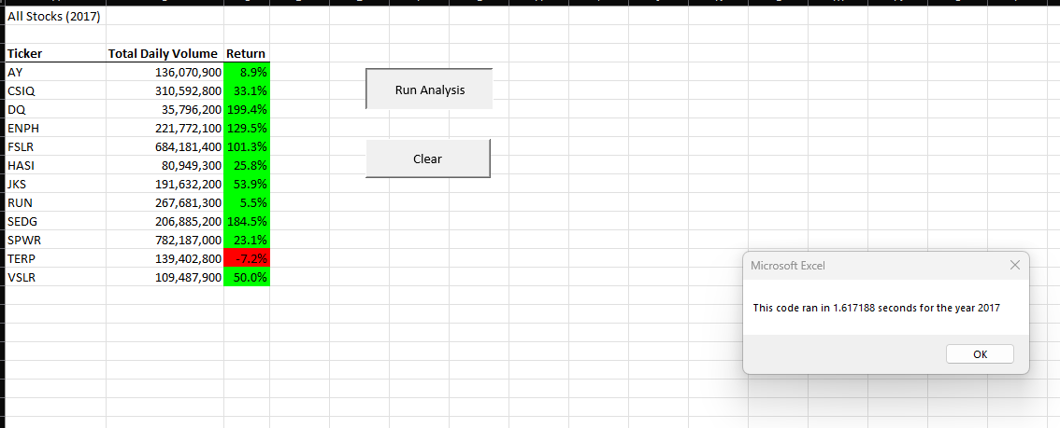

The results for the 2018 results and run time were 1.90625 seconds: 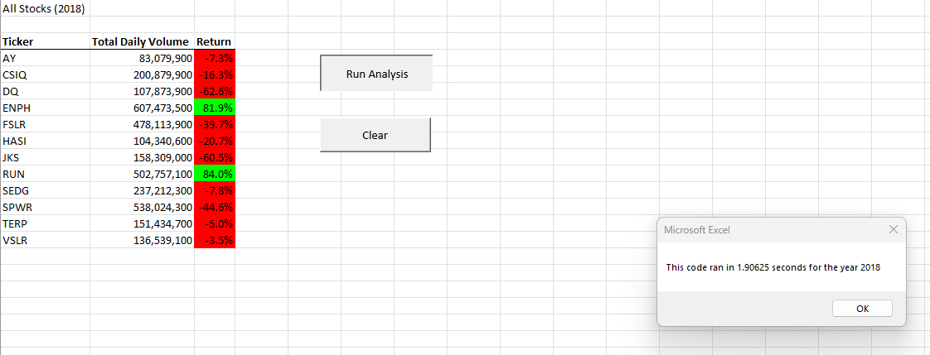

I believe the portion of the code that created these results is:

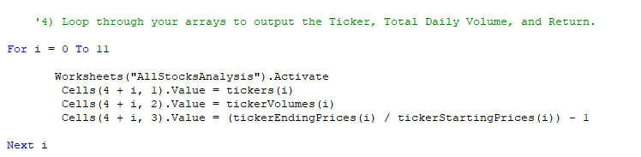

I am not sure but there may have been a way to make this more efficient although I was not able to find one.

Summary:

There are advantages and disadvantages to using refactoring code. This allows for more efficiency because you are not beginning from nothing, so long as the source code is correct then the refactored code should be sound. The disadvantage as I have alluded to is when that code that is being sourced is not correct or has errors in it. When this is encountered. First you must isolate the errors and correct the code, then you can adjust it to what is required.

The advantages of using refactoring VBA script from a practical point of view is that the code can be sourced from multiple sources and has material to compile in a more efficient manner. The disadvantage is that not all that code is going to be correct. VBA is not the most forgiving when it comes to errors in coding. The debugging process will stop the macro or code as soon as there is something that VBA “does not like;” this can be particularly complicated because VBA does not give any specific hints as to whether the error was in syntax for the entire code or just a line or if there is an issue in the logic that is being used. I lost quite a bit of time looking for errors and often it was just that there was an extra letter or misspelling that threw off the whole macro.